**FAST HOSPITAL MANAGEMENT SYSTEM**



**GROUP MEMBERS:**

**Syed Ali Jodat (20K-0155)**

**Abdul Ahad Shaikh (20K-0319)**

**Muhammad Basil Ali Khan (20K-0477).**

**Date of Submission:**

**5th December 2022**

**FAST HMS focuses on making an easy and interactive application for its users. There are 5 main users to this application.**

1. **Admin.**
2. **Patient.**
3. **Doctor.**
4. **Pharmacist.**
5. **Random Buyer.**

**FRONT PAGE:**

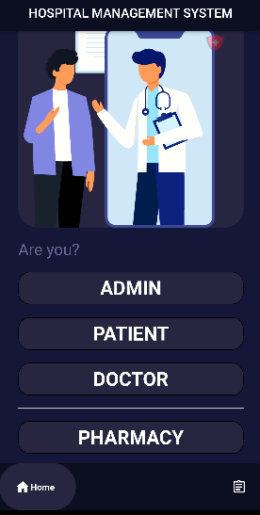

**ADMIN:**

**Login Page:**

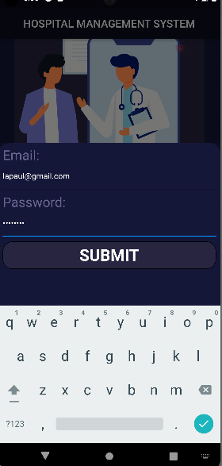

**Admin can login to the system by adding their email and password assigned to them whenever they very appointed.**

**Admin can do the following Stuff:**

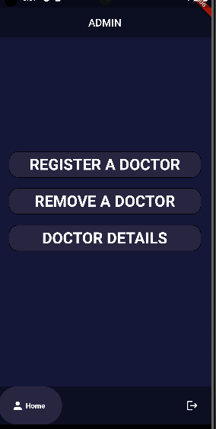

1. **Register a doctor that has applied for their job through CV’s.**
2. **Remove an existing doctor through their doctor ID and name.**
3. **View an existing doctor’s details who is working for FAST HMS.**

**Patient:**

**Login/Register Page:**

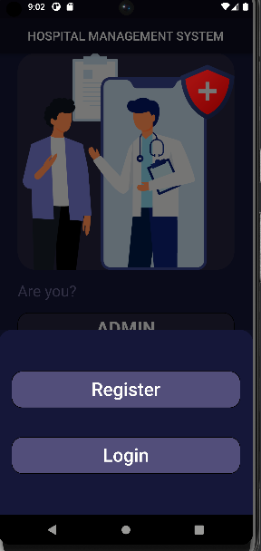

**A Patient has to register on our database and then Login through their id and pass which they have created.**

**Patient Can do the Following stuff:**

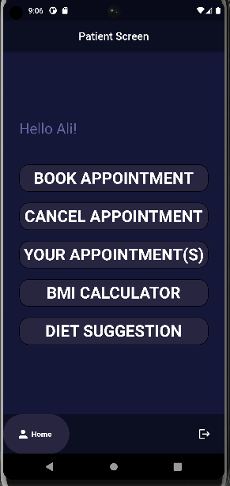

1. **Book Their Appointment According to their symptoms. A doctor will be assigned according to their disease/symptom.**
2. **Cancel their Appointment which they have booked-in.**
3. **View All Appointments that the patient has booked for self.**
4. **Calculate their BMI.**
5. **Diet Suggestions for Associated Symptoms.**

**Doctor:**

**Login Page for Doctor:**

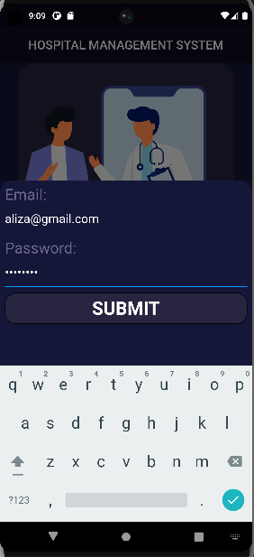

**Doctor has to login to the id and password assigned to them. Doctors can apply through emails at [fasthms@gmail.com](mailto:fasthms@gmail.com)**

**Doctor Can Do the Following stuff:**

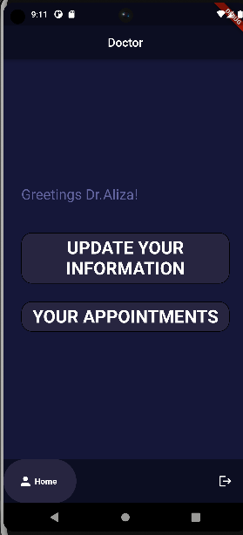

1. **Update your Current Information such as name,email, password, etc.**
2. **View their coming appointments in assigned time slots, specific dates of appointments, and the total number of appointments in their schedule.**

**Pharmacist:**

**Login Page for Pharmacist:**

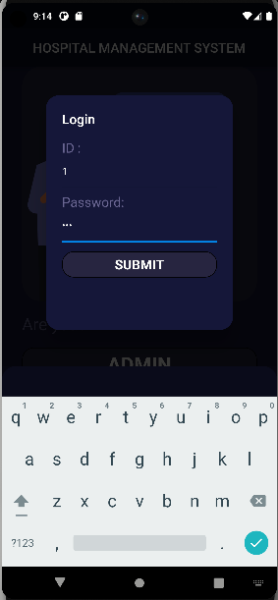

**Doctor has to login to the id and password assigned to them. Doctors can apply through emails at [fastphms@gmail.com](mailto:fasthms@gmail.com).**

**Pharmacists can do the following stuff:**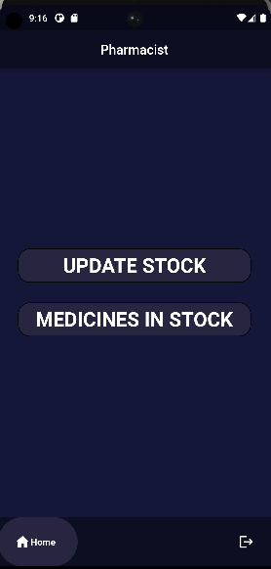

1. **Update the stock of the following medicines.**
2. **Check the no of medicines in stock**

**Random Buyer:**

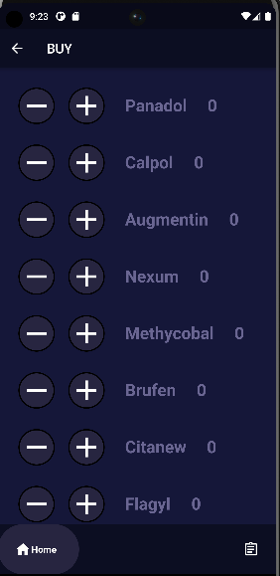

**A Random User Can Buy Any Medicines that he/she wants. After that a token will be generated against their order. Later he can collect those medicines from pharmacy at our pharmacy locations that are accros all over the city.**